|  |  |
| --- | --- |
| **Project Title** | **OFFFICES FOR PS-5 BLOCK 4 PROJECT AT PS-5 CONTROL AND ADMINISTRATION BUILDING** |
| **Document No** |  |
| **Contractor Name** | **AL AHLIA CONTRACTING COMPANY** |
| **Contractor Project Manager/contact details** | **RANGEETH RAVINDRAN (870810855)**  **MOB NO :-38307847**  **SABAREESH RAVINDRAN**  **MOB NO :-38994196** |
| **Contractor HSE Officer/contact details** | **SHINAS P K (950546119)**  **MOB NO:-33156741** |
| **Alba Responsible Engineer/contact details** | **UNNIKRISHNAN A** |
| **Purchase Order Number** | **S/45255875** |

|  |  |  |  |  |
| --- | --- | --- | --- | --- |
| **REV: 00** | **Prepared by** | **Initial Approval** | **Final Review** | **Final Approval** |
| **Date** | **01/05/2022** | **03/05/2022** |  |  |
| **Name** | **SHINAS P K** | **SABAREESH RAVINDRAN** | **UNNIKRISHNAN A** | **ZAKARIYA AHMED** |
| **Designation** | **Contractor’s HSE Officer** | **Contractor’s Project Manager** | **Alba Responsible Engineer** | **Engineering SHE Coordinator** |

**Contents**

**1.** **Project Information** 2

**1.1** **Scope of work** 2

**1.2** **Location** 2

**1.3** **Project Schedule** 3

**1.4** **Contractor Organization Chart** 3

**2.** **Monthly Construction Activities** 3

**3.** **Safety, Health and Environment Monitoring Records** 3

**3.1** **Project Leading and Lagging Indicators** 3

**3.2** **Details of Incidents** 4

**3.3** **Key update on Safety, Health, Environment and Fire** 4

**3.4** **Waste Record** 4

**3.5** **Waste Water** 4

**3.6** **Spills Response and Contaminated Land** 5

**3.7** **Mock Drill Records on Fire, Safety, Health, Environment** 5

**3.8** **Training Record on Safety, Health and Environment** 5

**3.9** **Photos of SHE and Construction Activities** 6

**4.** **Attachments** 6

**4.1** **Monthly Site Inspection form completed (to including photos)** 6

**4.2** **Temporary site establishment inspection completed (if any).** 6

# **Project Information**

## **Scope of work**

The scope of work is to construct offices for PS-5 block 4 and toilet modification at PS-5 Control and administration building. All activities of supplying and fixing of raised flooring, false ceiling, fit out works,painting,airconditioning,earthing and lighting system, toilet modification is done for this. All the work is executed in accordance with Health, Safety & Environmental Action Plan.

## **Location**

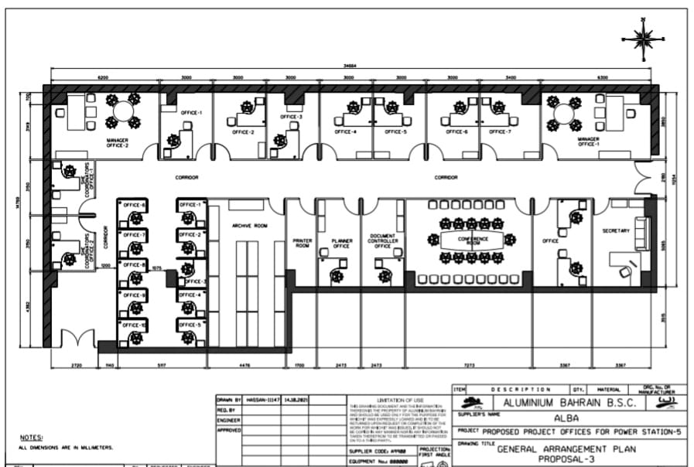

Offices for block4

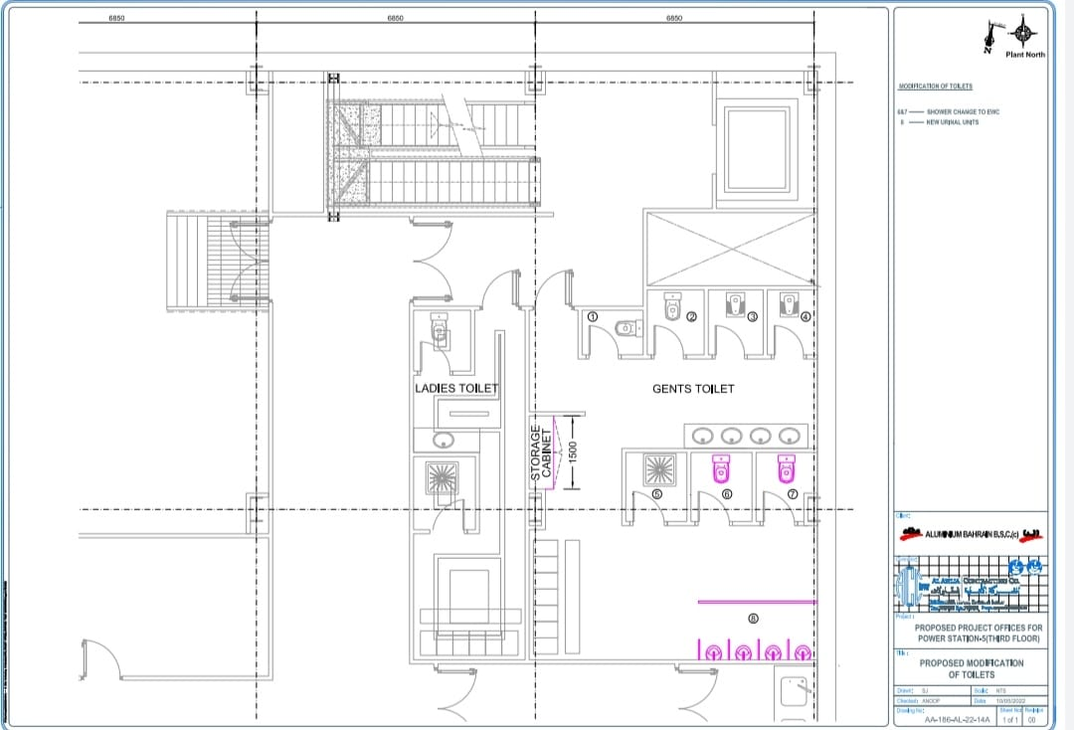

Toilet modification work

## **Project Schedule**

|  |  |  |
| --- | --- | --- |
| **Sl no:** | **Date** | **Activity** |
| 1 | 03-05-2022 | Ac ducting work started |
| 2 | 11-05-2022 | False ceiling work started |
| 3 | 15-05-2022 | Tile breaking started for the toilet work |
| 4 | 15-05-2022 | Electrical cable tray cable line work commenced |
| 5 | 22-05-2022 | Cutting of wall panel, for installation of air conditioning platforms |
| 6 | 23-05-2022 | Raised floor work commenced |

## **Contractor Organization Chart**

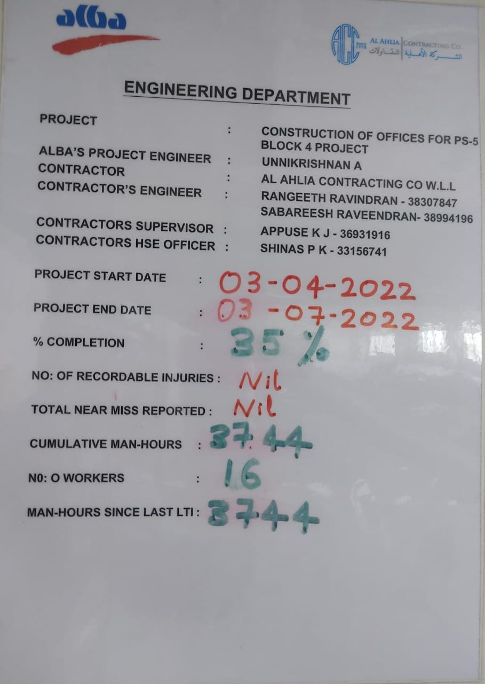

# **Monthly Construction Activities**

## **Activity 1**

Ac ducting work started

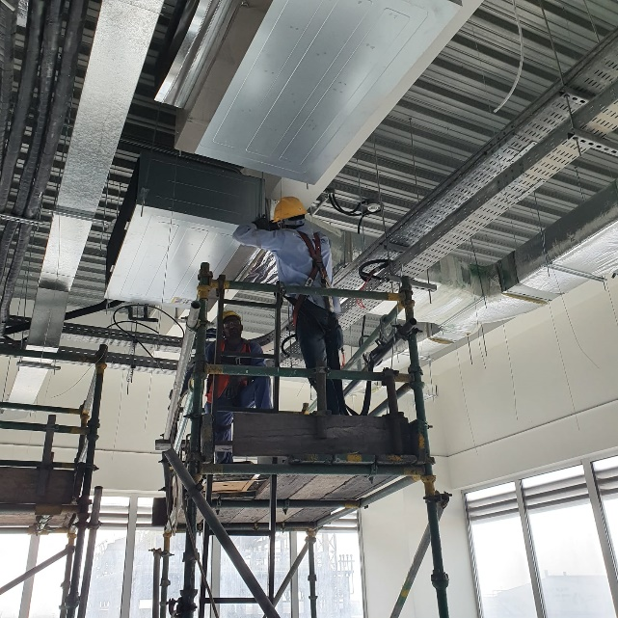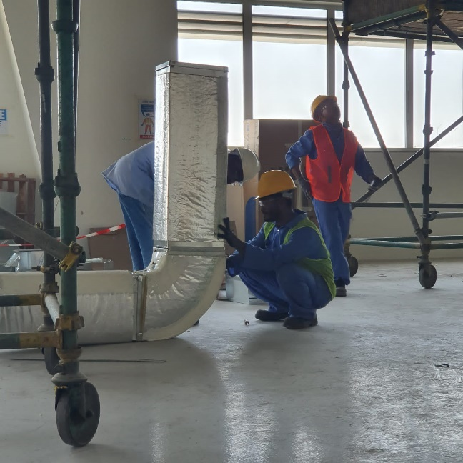

## 

## **Activity 2**

## **Activate 3**

# **Safety, Health and Environment Monitoring Records**

## **Project Leading and Lagging Indicators**

|  |  |  |
| --- | --- | --- |
| **Lagging Indicators** | **Monthly** | **Inception to Date** |
| Work hours | 264 | 264 |
| Work hours without LTI | 264 | 264 |
| Lost Time Injury | NIL | NIL |
| Restricted Work Injury | NIL | NIL |
| Medical Treatment Injury | NIL | NIL |
| Recordable Injury* | NIL | NIL |
| First Aid Injury | NIL | NIL |
| LTI Frequency Rate ∞ | NIL | NIL |
| Recordable Injury Frequency Rate ∞ | NIL | NIL |
| Near Miss Recorded | NIL | NIL |
| High Potential Near Miss Recorded | NIL | NIL |
| Vehicle Incident | NIL | NIL |
| Property Damage | NIL | NIL |
| Environmental Incident | NIL | NIL |
| Fire | NIL | NIL |

* Recordable Injury = Lost Time Injury + Restricted Work Injury + Medical Treatment Injury

∞ Frequency Rate = Number of injuries per 200,000 hours worked

|  |  |  |  |
| --- | --- | --- | --- |
| **No.** | **Leading KPI** | **Monthly** | **Inception to date** |
| 1 | Number of Monthly HSE Meeting | 3 | 6 |
| 2 | Number of weekly site HSE inspections | 2 | 7 |
| 3 | Number of weekly tools/Equipment inspections | 7 | 13 |
| 4 | Number of employee received project induction | 1 | 5 |
| 5 | Number of weekly toolbox talks | 23 | 72 |
| 6 | Number of HSE walk-downs by project Management | 4 | 11 |
| 7 | Number of site observations | 8 | 8 |
| 8 | % of HSE corrective actions vs observation | 100% |  |
| 9 | % of training completed vs planned | 90% |  |
| 10 | HSE Training (Man-hours) | 4 |  |
| 11 | % of Mock drill plan compliance | NILL |  |
|  | Number of Average manpower | 5 | 5 |

## **Details of Incidents**

Nil

## **Key update on Safety, Health, Environment and Fire**

1. Daily tool box talk are taken before the work .We just summarize the details of the work, related hazards that can occur during the work and its preventive measures. One new worker join in the team for him we provide a separate site specific induction which is necessary for the site

2. We had reported 2 near miss in the month of October to our ALBA project engineer, Miss Sara Ebrahim. Followed by my report, Miss Sara Ebrahim, ALBA superintend Samal conducted a safety meeting with our team.

## **Waste Record**

|  |  |  |  |  |  |
| --- | --- | --- | --- | --- | --- |
| **#** | **Type of Waste** | **Description of the Material** | **Quantity of Waste (Kg)** | **Transferred by Approved Waste Handler**  **(Yes or No)** | **Destination Name of Landfill/ Recycle/ Incineration facilities**  **(Provide Tracing Evidence) and photos** |
| **1** | Recyclable | NIL |  |  |  |
| **2** | Hazardous | NIL |  |  |  |
| **3** | Disposable | NIL |  |  |  |
| **4** | Incineration | NIL |  |  |  |
|  | **Total** |  |  |  |  |

## **Waste Water**

|  |  |  |  |  |
| --- | --- | --- | --- | --- |
| **#** | **Type of Waste** | **Quantity of Wastewater Transferred to STP (KL)** | **Transferred by Approved Waste Handler**  **(Yes or No)** | **Destination – Name of Sewage Treatment Plant** |
| **1** | NIL |  |  |  |
|  | **Total** |  |  |  |

## **Spills Response and Contaminated Land**

|  |  |  |  |  |  |
| --- | --- | --- | --- | --- | --- |
| **#** | **Spillage Event Explanation** | **Date of Spillage Event** | **Quantity of Hazardous Waste Stored at site (Kg)** | **Quantity of Hazardous Waste Transferred to Landfill (Kg)** | **Name of Landfill facilities** |
| **1** | Nil | Nil | Nil | Nil | Nil |
|  | **Total** | |  |  |  |

## **Mock Drill Records on Fire, Safety, Health, Environment**

|  |  |  |  |
| --- | --- | --- | --- |
| **Mock Drills No.** | **NIL** | **Date** |  |
| **Emergency Type** |  | | |
| **Location** |  | | |
| **Company** |  | | |
| **Scenario** |  | | |
| **Observations** |  | | |
| **Photos** |  |  | |

## **Training Record on Safety, Health and Environment**

| **Monthly** | | | | | |
| --- | --- | --- | --- | --- | --- |
| **Sl. No.** | **Trainings Course** | **Duration** | **Hours** | **Number of**  **Attendees** | **Total**  **Attendees** |
| **1** | Nil |  |  |  |  |
| **2** | Nil |  |  |  |  |
|  | **TOTAL** |  |  |  |  |

| **Inception to Date** | | | | | |
| --- | --- | --- | --- | --- | --- |
| **Sl. No.** | **Trainings Course** | **Duration** | **Hours** | **Number of**  **Attendees** | **Total**  **Attendees** |
| **1** | Nil |  |  |  |  |
| **2** | Nil |  |  |  |  |
|  | **TOTAL** |  |  |  |  |

## **Photos of SHE and Construction Activities**

|  |  |
| --- | --- |
| 1 | C:\Users\sekhar\Desktop\ccctv11.jpg |
| **Flag man assigned for safe traffic** |
| 2 | C:\Users\sekhar\Desktop\comprssor alba.jpg C:\Users\sekhar\Desktop\ccmp.jpg |
| **Compressor inspection** |
| 3 | C:\Users\sekhar\Desktop\cctv tbt.jpg |
|  | **Our daily TBT** |

* 1. **Next Month Safety Focus and planning**

We are planning to conduct a small class on safe manual lifting procedure and things to follow while working with ladder. We have observed small mistakes while manual lifting and ladder usage by the workers.

# **Attachments**

## **Monthly Site Inspection form completed**

**Compressor check list**

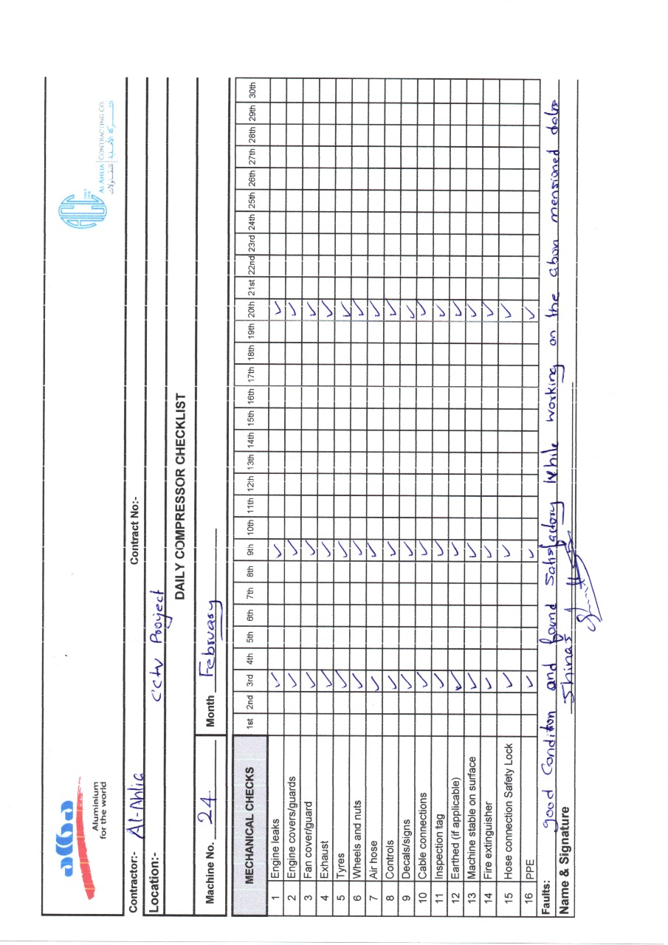

**Random PPE check list**

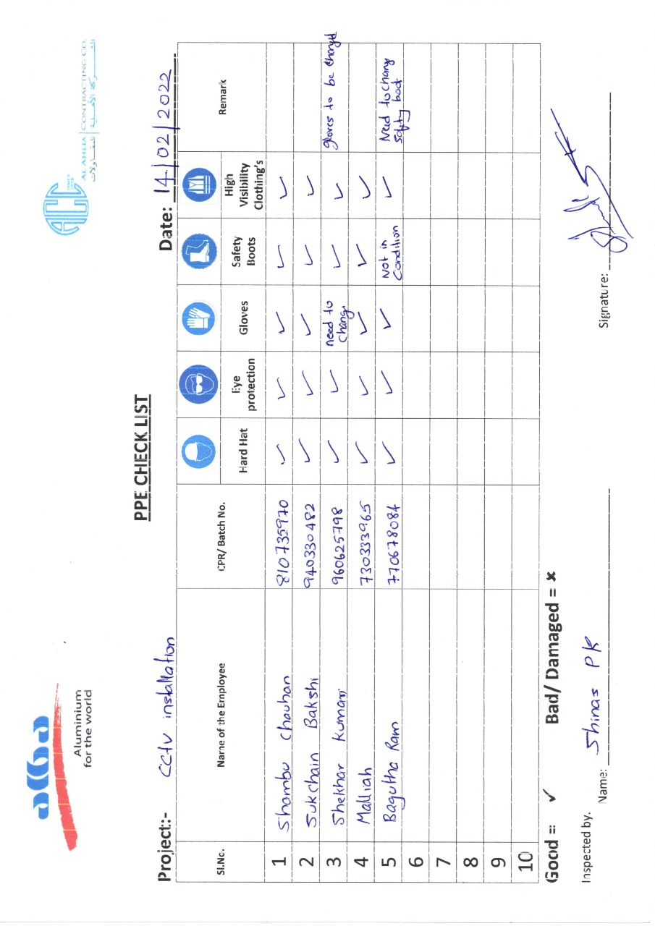

## **Temporary site establishment inspection completed**

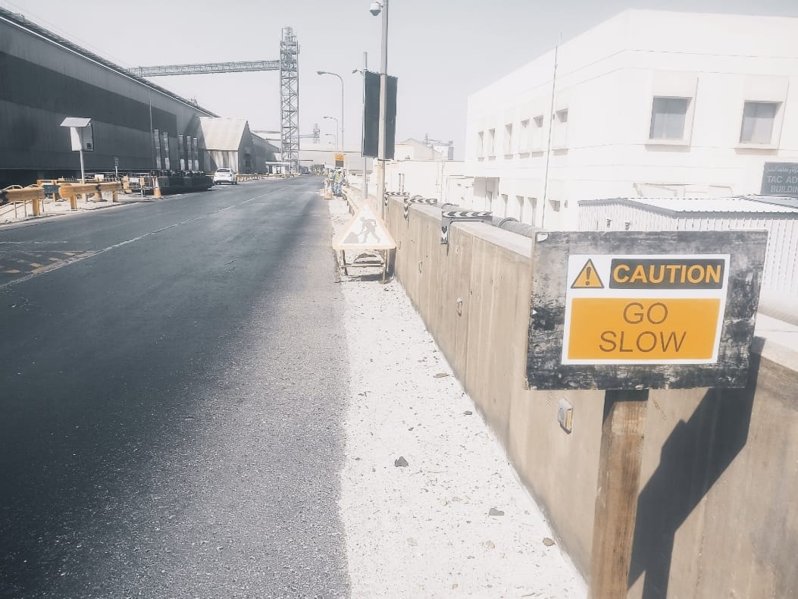

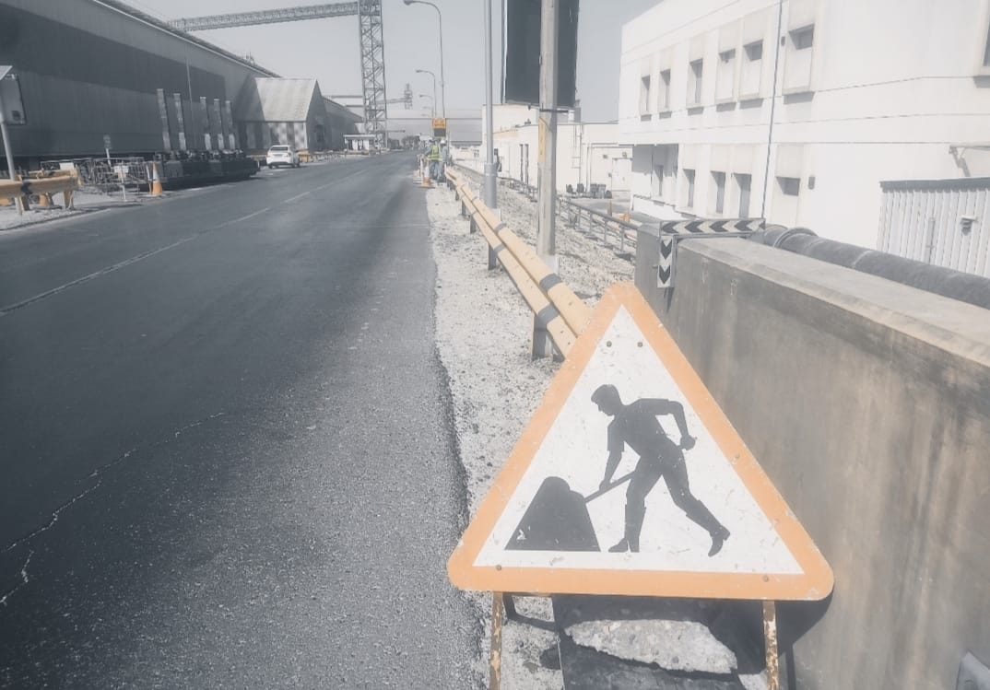

**Caution sign boards where kept for the safety of our team**